Algorithms DataStructure (Mandatory Hands On)
Exercise 1: Inventory Management System
Program.cs
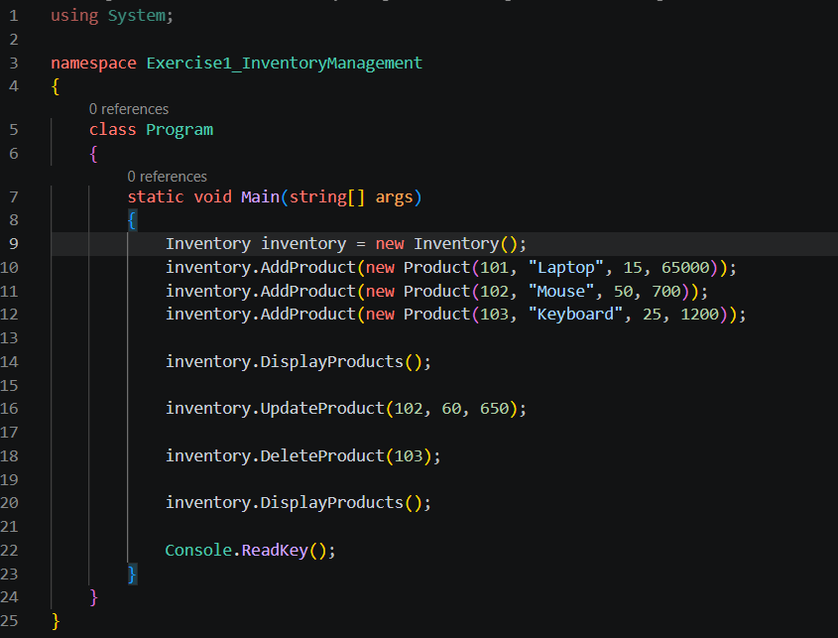
Inventory.cs
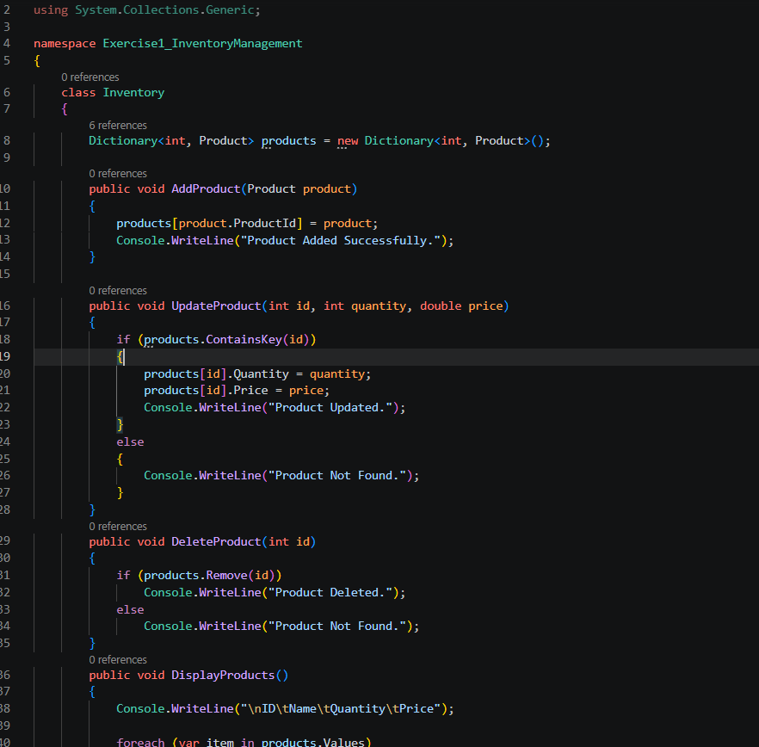
Product.cs
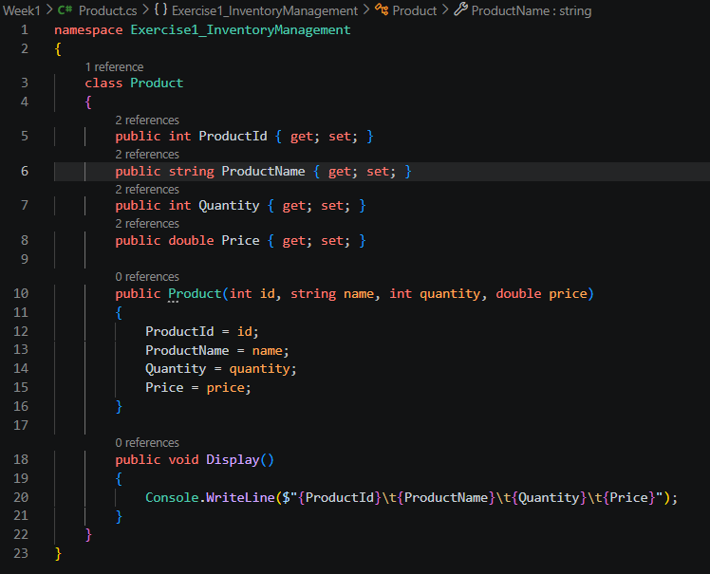
Output:
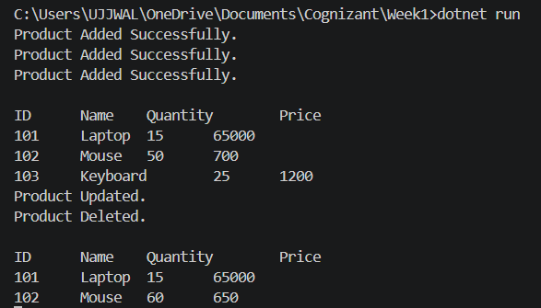

Exercise 2: Inventory Management System
Program.cs
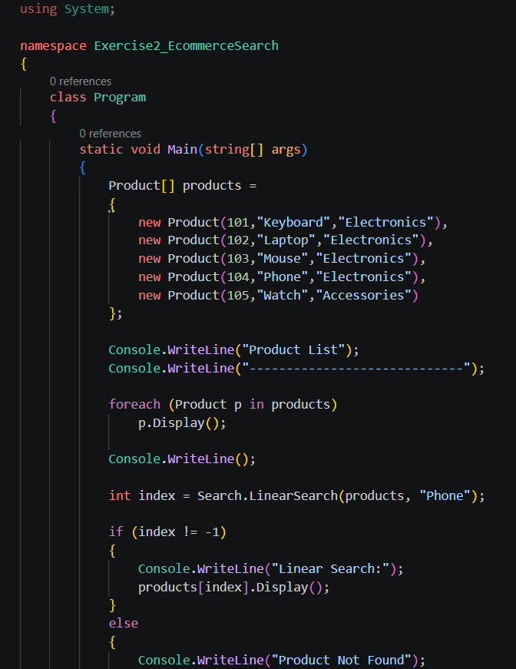

Product.cs
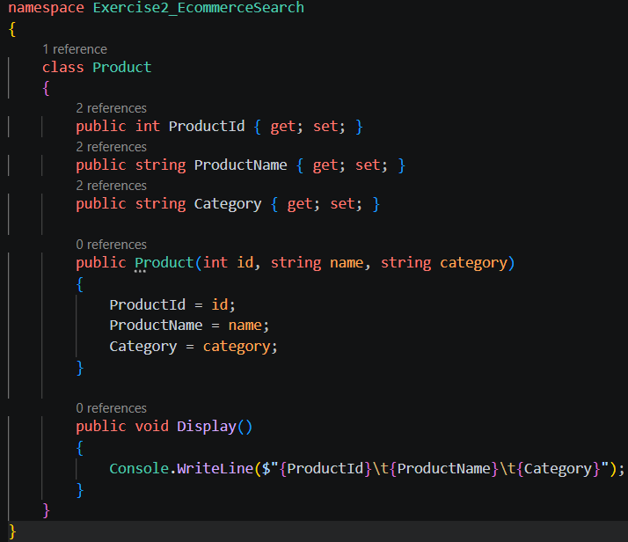
Search.cs
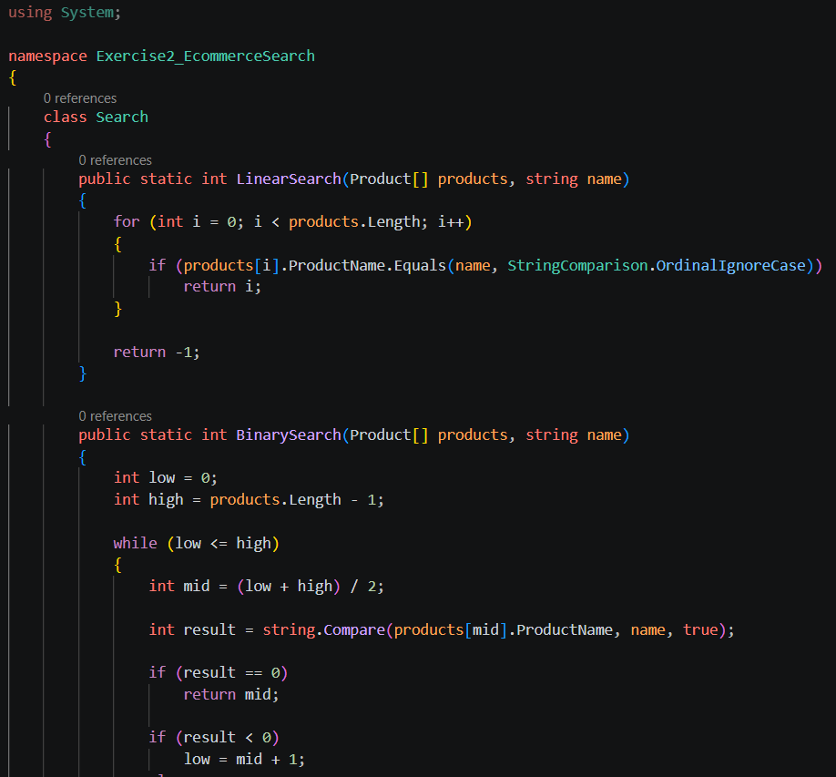

Output:
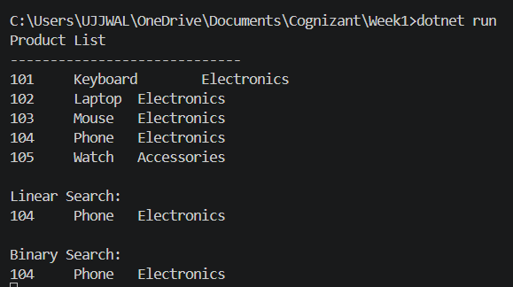
Exercise 3 - Sorting Customer Orders
Order.cs
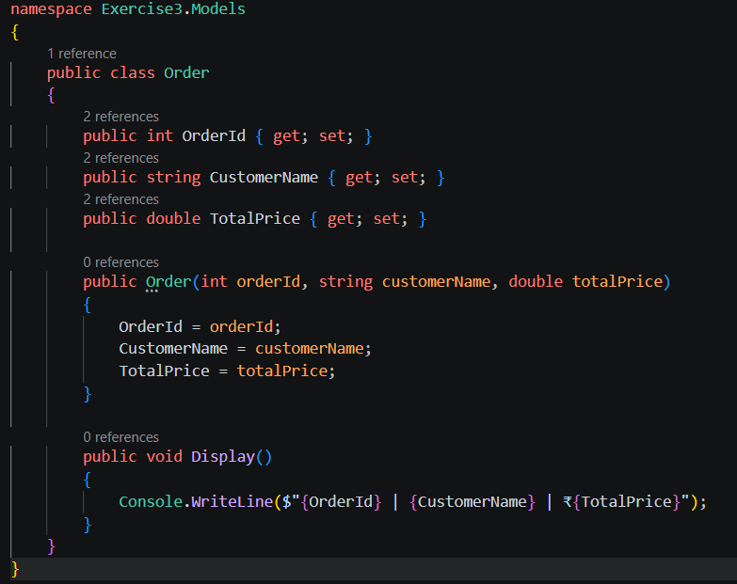
SortService.cs
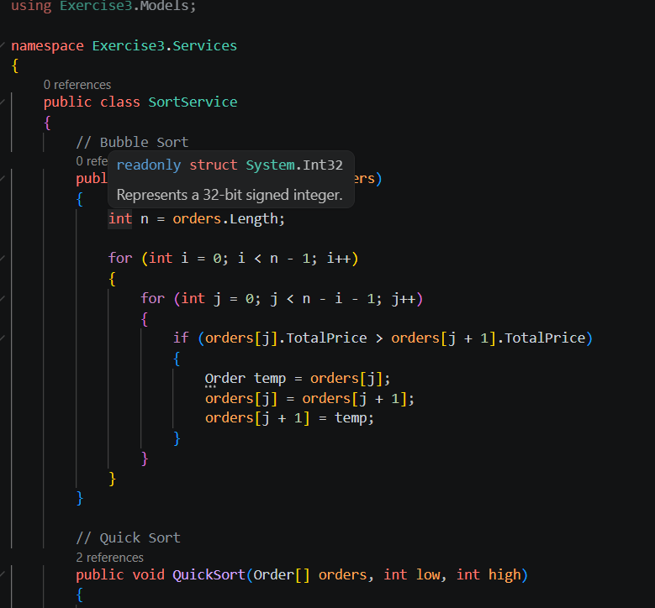
Program.cs
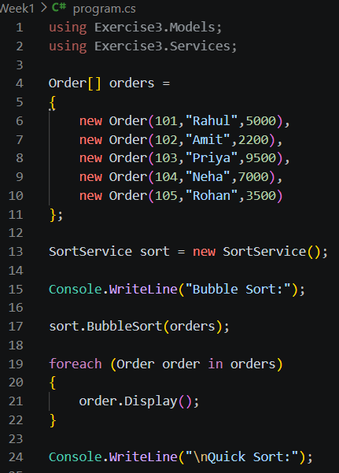
Output
Exercise 4 - Employee Management System
Employee.cs

EmployeeService.cs
Program.cs
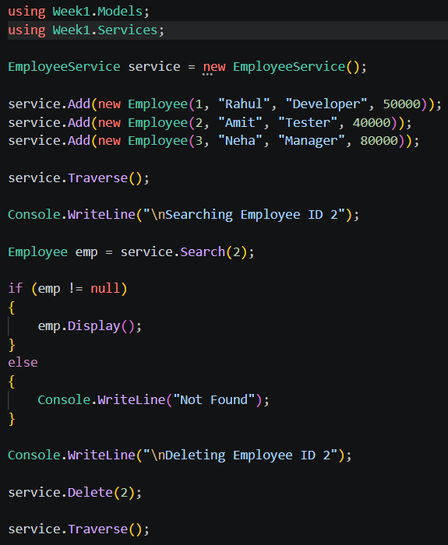
Output
Exercise 5 - Employee Management System
TaskNode.cs
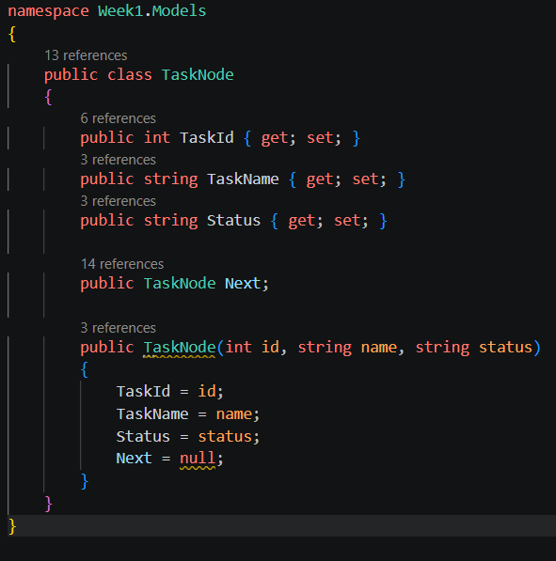

TaskLinkedList.cs
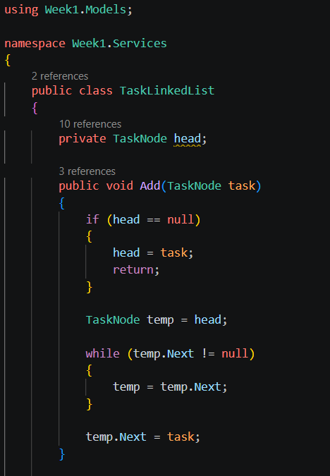
Program.cs
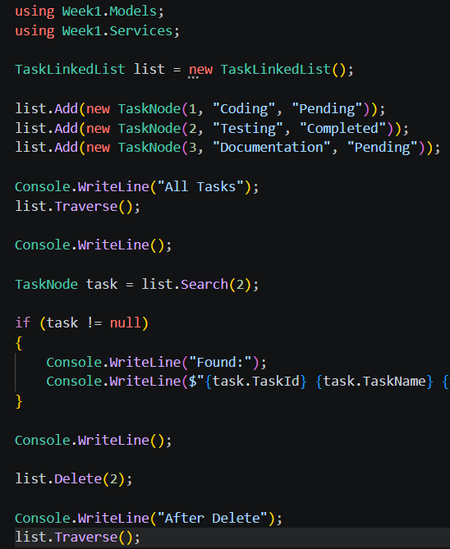
Output
Exercise 6 - Library Management System
Book.cs
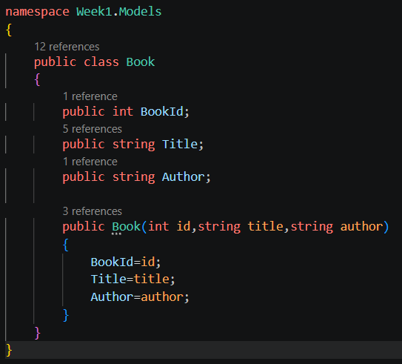

SearchService.cs
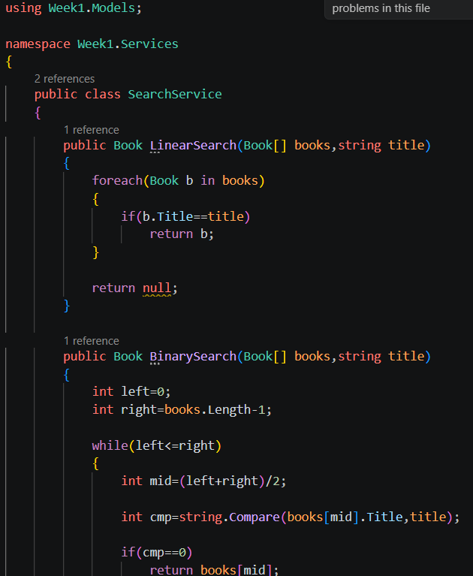

Program.cs
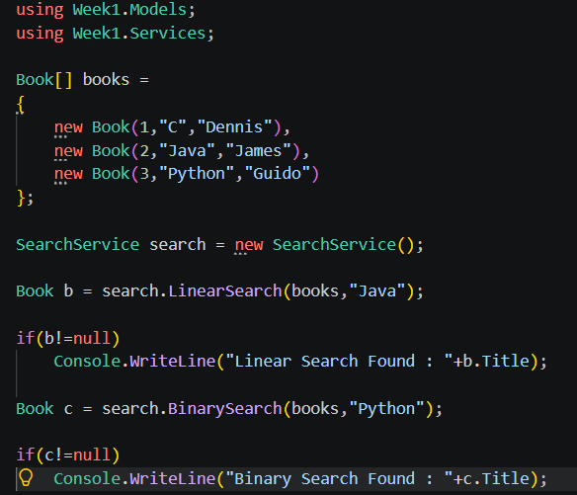
Output
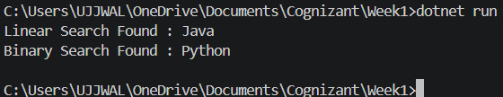
Exercise 7 - Financial Forecasting
ForecastService.cs
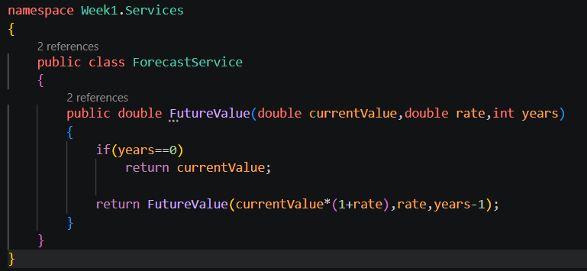
Program.cs
Output
